**St Brigid’s Primary School, The Coombe**

**School Calendar 2025/26**

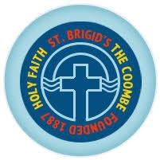

|  |  |
| --- | --- |
| **Wednesday 27th August 2025** | School Reopens – Start of new school year  (Junior Infants - 6th class) |
| **Thursday 28th August 2025** | Early Start begin their school year |
| **Monday 27th October – Friday 31st October (inclusive)** | Midterm/Halloween Break |
| **Monday 3rd November 2025** | School reopens after Halloween Break |
| **Friday 19th December 2025** | School closes at 12pm for Christmas holidays |
| **Monday 5th January 2026** | School reopens after Christmas holidays |
| **Monday 2nd February 2026** | School closed - Public holiday  (St. Brigid’s Day) |
| **Thursday 19th and Friday 20th February 2026** | School closed for midterm break |
| **Monday 16th and Tuesday 17th March 2026** | School closed – long weekend for St Patrick’s  Day |
| **Friday 27th March 2026** | School closes at 12pm for Easter holidays |
| **Monday 13th April 2026** | School reopens after Easter holidays |
| **Monday 4th to Friday 8th May 2026** | School closed for full week |
| **Monday 1st June 2026** | School closed – Public Holiday |
| **Friday 26th June 2026** | School closes at 12pm for summer holidays |